CSA Retiree Chapter - Queens Regional Unit

Cordially invites you to meet and greet your friends at
our annual luncheon meeting at
Terrace On the Park
Flushing Meadows Park, N. Y. 11366
Wednesday, October 07, 2026
12:00 – 3:30 p.m. (718) 592-5000

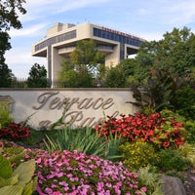
Guest Speakers
Susan Barone, Administrator, CSA Welfare Fund
Mark Levine, Comptroller, New York City

Enjoy a reception with hors d’oeuvres followed by a complete luncheon with choice of entrées.
Wine, soda, and a cash bar will be available.
Gift baskets and 50/50 Raffle will be held for the CSA Irwin Shanes Scholarship Fund
QRU members $60.00 Non-members $80.00
Payment must be received no later than September 30, 2026
These prices reflect a significant subsidy of the luncheon cost. Please do not send cash.
There will be no admittance without a prior reservation at the door. Space is limited.
Checks should be made payable to CSA Queens Retirees and mailed to:

Leonard B. Sterman
77-15 251st Street
Bellerose, New York 11426

Dear Len,
I/We will attend the Annual Luncheon Meeting on Wed., October 7, 2026.

Name(s)_____________________________________________________ Phone _______________________

Amount Enclosed _________________________ Member ______ Non-member______

Please seat me with __________________________________________________________

Seating preferences cannot be accommodated the day of the luncheon.

