CSA Retiree chapter - queens regional uniT

Bridge for intermediate players

For members of the CSA Queens retiree unit

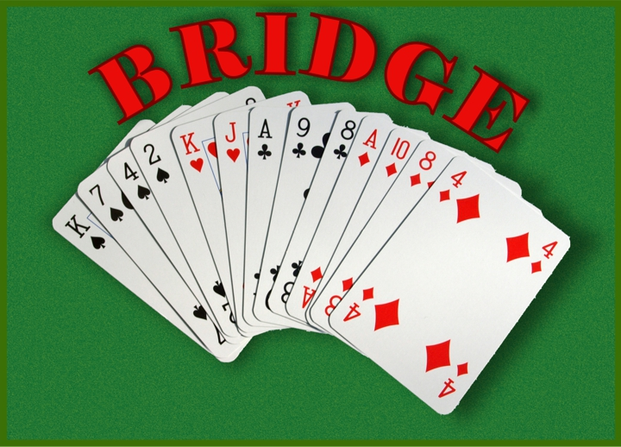

lessons will be conducted by
Lilian Garelick
(master bridge player)
on
February 2nd, 9th, 16th, and 23rd
@ 1:00 P. M.

LOCATION:
North Shore Towers
Building #3 Coleridge Lounge
269-10 Grand Central Parkway
Floral Park, New York 11005

Reserve your place by contacting Lilian Garelick
At (917) 306-4946

Or emailing her at:
liliangarelick@gmail.com

